Abstract
This is a stand alone application developed using Java for Amazing Destination Travel (Pvt) Ltd to manage their vehicle reservations. This system will be used by Travel Guides, Transport Officers & System Administrator. Travel Guides can add new vehicle requests & view previous requests. Transport Officers can respond to vehicle requests, manage Travel guides / Vehicles Information & generate two kinds of reports. System Administrator can manage all user profiles of Travel Guides, all user profiles of Transport Officers, and Vehicle Information. Whenever any user wants to use the system, he/she need to login to the system using a username & password. All data will be saved in a MySQL database, which can be accessed by the system.

Introduction
New Vehicle Reservation System was developed to meet the following features.
- Efficiency and easy to use
- Add, delete and update information on database
- Generate Reports with one click
- Information Security
This System is developed using Java programming language. Netbeans IDE 7.1.1 is used to develop the system. This system can be used to manage vehicle reservations of Amazing Destination Travels (Pvt) Ltd, in an easier & accurate way.
The System source code used 3 packages. Data, GUI & Images.
- Package Data contains eight classes.

- DBConnect
This is used to establish the connection between System & MySQL database.
- DBAccess
This class is used to access database using several methods, to read write & delete data on database.
- Vehicle
This class is used to create an object which holds vehicle data. This is defined as a sub class of DBAccess class.
- User
User is a class used to create a user object. This is also a sub class of DBAccess class.
- Templogin
Templogin is used to hold information about current logged in user. Temlogin is also a subclass of DBAccess class.
- TransportOfficer
TransportOfficer is a sub class of User.
- TravelGuide
TravelGuide is also a sub class of User.
- ViewReports
This class is used to generate reports using IReports.

- Package GUI contains four user interfaces.

- Home
Home is the first window of the system.
- Transport Officer
All tasks of Transport Officers are performed on this interface.
- Travel Guide
All tasks of Travel Guides are performed on this interface.
- Administrator
All System Administrative tasks are performed on this interface.

- Package Images contains some image files used in the interfaces.

The System will be able to access MySQL database. The database ‘test’ will be used by the system to store data.

This system will generate two reports using iReport-3.7.6.
- All Vehicles information.
A report will be generated containing information about all the vehicles of Amazing Destination (Pvt) Ltd. This report includes Type of the vehicle, Registration number, Number of seats & Driver’s name.
- Total Reservation made for a vehicle during a specified time period.
Here, user system will be given a registration number & a time period. System will find all reservations made during the time period for the vehicle, & generate the report. This report will include request number of each request, vehicle registration number, reserved travel guide, reserved time period, approved transport officer & approved date/time.

Database Design
Vehicle
TravelGuide
Transport
Officer
Reserve
Vehicle type
No_of_seats
driver
reg_No
to
from
userame
password
name
address
contract_end_date
Approve
Approved date time
Is_Approved
employement_date
username
password
name
salary
request_no

ER - Diagram

Tables created
- Travel Guide
- Vehicle
- Transport Officer
- Reserve
Constraints
- Vehicle_PK (reg_No) - primary key of Vehicle
- TravelGuide_PK(username) - primary key of TravelGuide
- TransportOffocer_PK(username) - primary key of TransportOfficer
- Reserve_PK(vehicle,travel_guide, from_date, to_date) - primary key of Reserve
- Reserve_Vehicle_FK(vehicle) - foreign key references to Vehicle(reg_No)
- Reserve_travel_guide_FK(travel_guide) - foreign references to TravelGuide(username)

Requirements Fulfilled

These requirements are fulfilled for the following users.
- Travel Guides
- Login to the system using a username & a password.
- Search available vehicles for a given number of passengers & given time period.
- Reserve an available vehicle.
- View status of previously made requests.
- Cancel a reservation made by him/her.

- Transport Officers
- Login to the system using a username & a password.
- View available new requests and approve/reject them.
- Insert, update & delete information about vehicles.
- Insert, update & delete information about Travel Guides.
- Generate reports to view information about all vehicles.
- Generate reports to view reservations made for a given vehicle during a give time period.

- System Administrator
- Insert, update & delete information about vehicles.
- Insert, update & delete information about Travel Guides.
- Insert, update & delete information about Transport Officers.

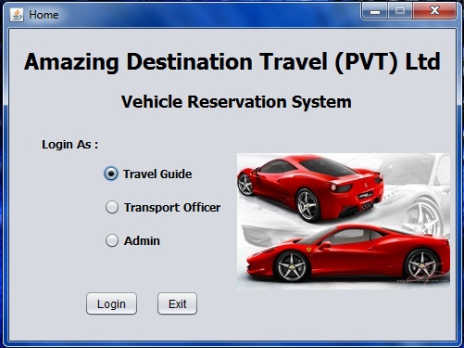
User Interface Design
Very attractive and user friendly interfaces are designed for users to handle their tasks in easy and efficient manner.
At the first window, user has to select which kind of a profile he/she will be using to Log into the System. It can be Travel Guide, Transport Officer or System Administrator.
Ones the user selected the profile type, System will be prompt user to insert username & password. Only for the Administrator, only the password will need to be provided.

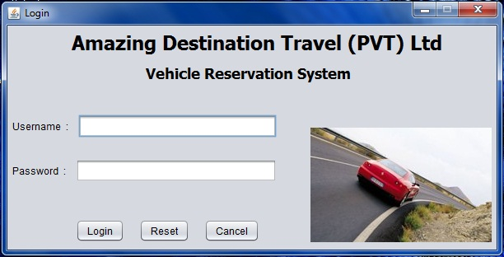
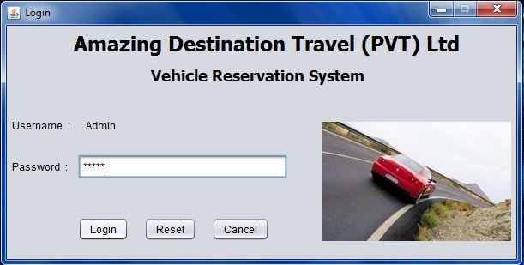

Travel Guides can log into the System using their username & password. After logging in, Travel guides can add new vehicle requests providing necessary information. The information will be
- Number of passengers
- Time period
- Vehicle type
If there any error in the time period the system will be notify the user. After providing all details, user can check for available vehicles for the given time period. Then user can select a vehicle and place the request.
Travel guides can view previous requests he/she has placed before. The system will notify the current status of the request. It can be accepted, rejected or pending respond.

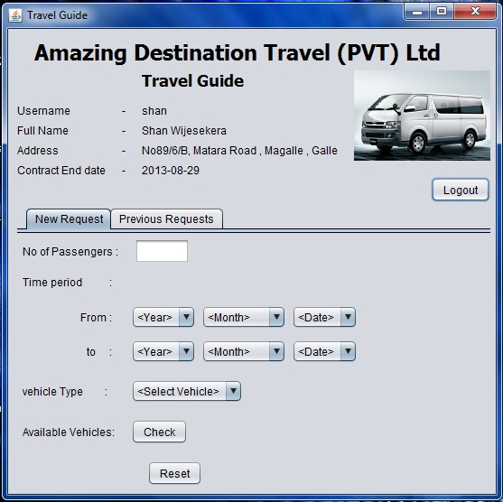

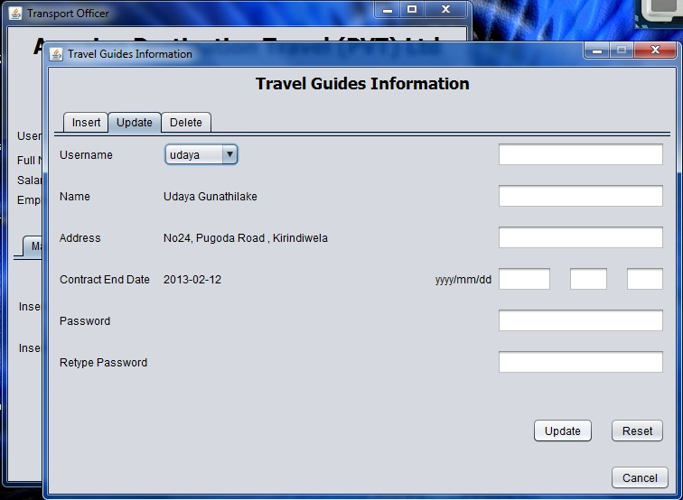
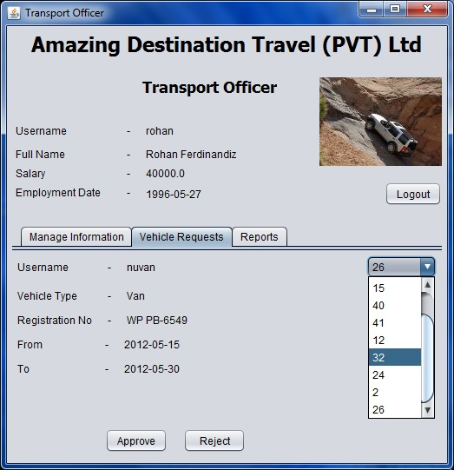

Transport Officers can log into the System by giving their username & password. After logging in, user can manage information about Vehicles & Travel Guides. This interface has two sub interfaces to handle the task. User can insert, update or delete information using these sub interfaces.
Then the user can see what are the new vehicle requests made by Travel Guides. User can accept or reject those requests.
Next, Transport officers can generate two reports about all vehicles & reservations for vehicles. These reports are described under the next topic.

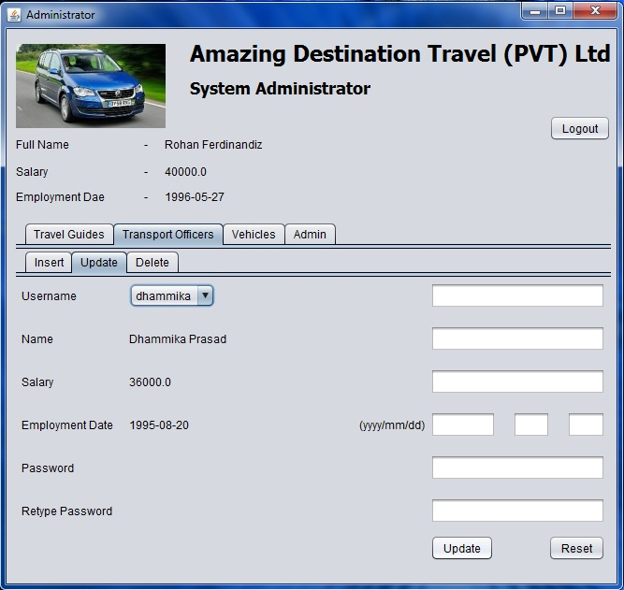
System Administrator can log into the System using a password. This password can be changed, but Administrators username cannot be changed.
System Administrator can insert, update or delete information about Vehicles, Travel Guides & transport Officers. Administrator can edit Admin profile too. But Administrator cannot handle vehicle reservation information.

Report Generating
Transport officers can generate two reports using this system. The system will be able to generate these reports using iReports-3.7.6. These reports are created in an attractive and user friendly theme, which can give the idea to the user instantly.
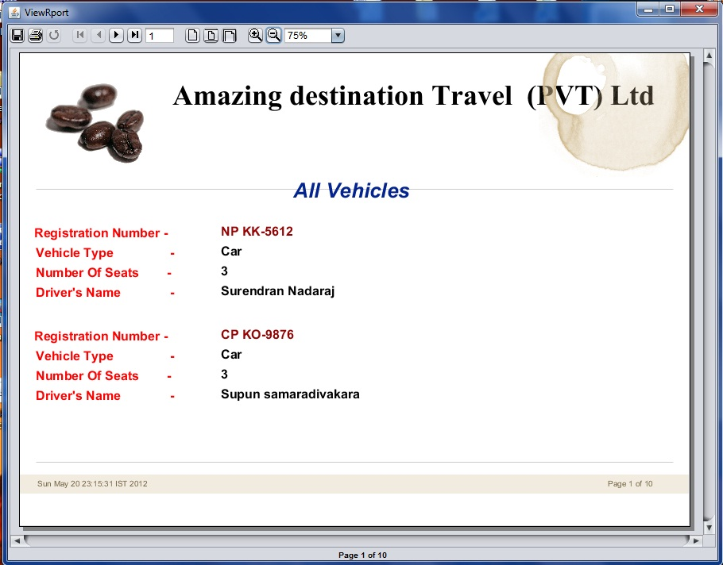
- All Vehicles
System will generate a report containing information about all the vehicles, currently owned by Amazing destination travel (Pvt) Ltd.

- Total Reservations for a Vehicle
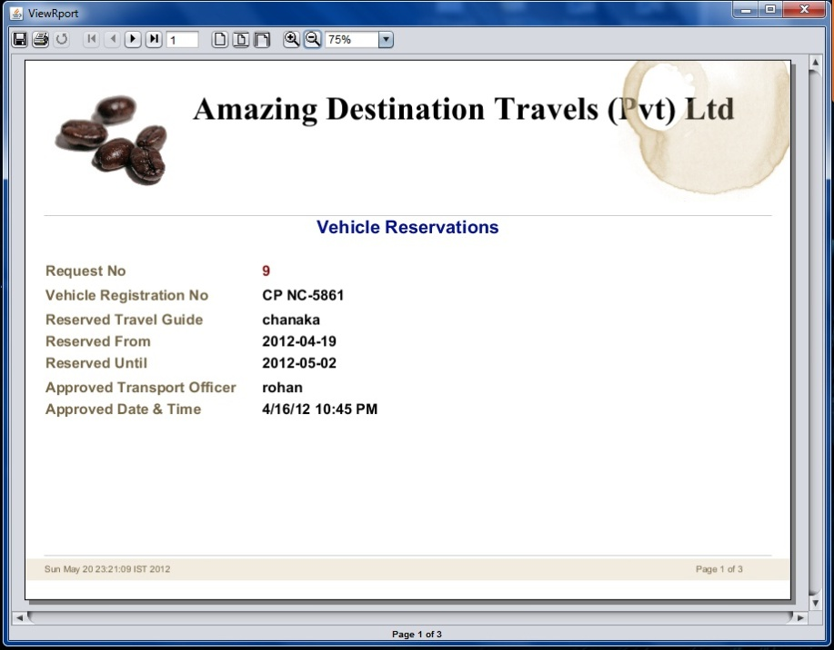
System will generate a report containing information about reservations made for a certain vehicle during a given time period. User can select a vehicle number, and user can insert a time period. System will generate the report according to the given parameters.

Problems Encounter

- According to the given requirements, any Transport officer can insert update or delete information about other Transport Officers. But for the security purposes, it cannot be allowed. Therefore a System Administrator is added to manage user profiles.
- This system cannot access a database other than “test” database connected via “jdbc:mysql://localhost:3306/”. The username and the password also cannot be changed. If the system had to be developed to meet the above requirement, according to developer’s knowledge, whenever user tries to access the system, user may have to insert them manually.

Conclusion
This assignment was a brilliant help to learn how to use JAVA programming language to do the following tasks.
- Create GUI Applications.
- Access a database from a software program.
- Generate reports using an additional generator such as iReports.
- Create a software program with Object Oriented form.
- Find and resolve errors while developing a software.
- Develop a Software system which can meet proper user requirements.
Finally it can be said that this assignment provided an excellent knowledge and experience.

